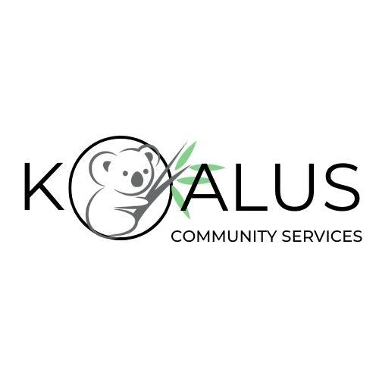
Participant Referral Form

Thank you for your referral to Koalus Community Services (KCS). To ensure we provide the most appropriate support to meet your needs, please complete the following form in as much detail as possible. If you would also like to attach a copy of your plan, this will assist us to further process your request.

The information you provide below will allow us to match you to consistent and quality staff with the skills and experience needed to support you or your participant towards achieving their goals.

Who is completing this referral form?
The Participant: |  | Someone Else:
If someone else, Who:
Name: Click or tap here to enter text.
Relationship/Organisation: Click or tap here to enter text.

Participant Information
First Name: |  | Surname:
Primary Contact Number: |  | Suburb/Location:
Date of Birth:  Disability/conditions:  Any addition information: |  | NDIS No:  What gender do you identify as: | Choose an item.

Support Coordinator (If Applicable)
Name:
Organisation: |  | Contact Number:
Email Address:

Support Services Requested
What Supports does the participant require:  If ‘Other’, please explain: |  | Choose an item.
How many hours a week are required:
Preferred day/s of support:  If ‘Other’, please explain: |  | Choose an item.
Preferred start and finish time: | From to OR Hours negotiable
Please list the participant’s interests, hobbies and what they enjoy doing:

Please describe what the participant does not enjoy doing and/or any triggers:

Further NDIS Details
NDIS Goals/Objectives:
(As stated in the NDIS plan)
How is the plan managed: | Plan Managed Self-Managed Agency Managed
Plan dates | to
Funding category to be utilized:
Plan Manager Agency (if applicable):
Plan Manager name (if applicable):
Contact information:

Please indicate (if applicable) any additional documents included with this referral:
- OT Report
- Behaviour Support Plan
- NDIS Plan
- Mental Health Plan
- Restrictive Practices
- Other:

Thank you for your referral and collaboration in supporting our community!
Please return this form to admin@koaluscs.com.au. We will contact you shortly.

Note: The information provided in this referral form will be treated with confidentiality and used solely for the purpose of providing services to the participant.

